**Introduction**

The species abundance distribution (SAD) is one of the very few ecological patterns whose consistency in shape makes it akin to an ecological law (Lawton, McGill, …). Across varied ecosystems and taxa, the species abundance distribution is nearly always dominated by a few very abundant species and a larger number of increasingly rare species, generating a distinctive hollow- or J-shaped curve (). Tempted by this remarkably general pattern, community ecologists have used the species abundance distribution to test numerous theories designed to determine which biological processes are most important for structuring assemblages of species (). However, using the species abundance distribution to infer underlying processes has proven frustrating because there is so little variation in the shape of this distribution, even in response to experimental manipulations (supp) and many theories produce similar predictions that perform comparably well when compared to observed distributions (McGill).

While ecologist have generally focused on explaining the species abundance distribution as emerging from ecological processes, accumulating evidence suggests that statistical constraints may be involved in generating the most striking feature of the species abundance distribution – the hollow curve. Frank () used a statistical mechanics framework to show that hollow curves, including a log-series – one of the most common mathematical approximations for empirical SADs – can easily be obtained as statistical by-products of [RMD forgets the precise process and needs to revisit Frank’s stuff]. Harte and associates () used the principle of entropy maximization to find the most-likely form for numerous ecological distributions, given sparse information about broad community properties and minimal assumptions regarding ecological mechanism. They also found that a log-series emerges as the most-likely form for the SAD (). This log-series is an excellent fit to empirical SADs (White et al 2012). Finally, Locey and White (2012) put forward an entirely non-biological derivation for the statistical constraint on the SAD. They leveraged the fact that there are a finite number of ways to divide *N* individuals among *S* species, and used combinatorics to characterize the range of *possible* forms for SADs, or feasible set, for realistic values of S and N. They showed that practically all feasible sets have strong central tendencies towards hollow curves ().

If, as seems to be the case, SADs are statistically driven to be hollow curves before biology even enters the picture, it is no surprise that we have struggled to interpret the hollow curve in biological terms. However, while the general shape of the species abundance curve may be statistically constrained, it is still possible that biological processes influence more subtle aspects of its shape – i.e. that biological processes push the species abundance distribution away from the most likely random outcome. If we can evaluate SADs not in terms of their absolute shape, but in terms of their shape *relative to what we would expect simply due to S, N, and the statistical constraint* (), then we can evaluate theories in terms of how well they predict the *deviations,* or how much additional predictive power they give us over and above what is inherent to S and N(). Conversely, if we cannot distinguish between observed species abundance distributions and their statistically-most-likely forms, there may be little information we can extract from the SAD alone.

Whether or not observed species abundance distributions differ from their most likely statistical form depends on the shape of the statistically generated distribution. By

Locey and White () laid a blueprint for evaluating SADs in the context of their statistical constraints. They drew samples from the *feasible set* – the set of *possible* divisions of N individuals into S species – and compared observed SADs to the central tendencies of their feasible sets. Locey and White’s initial efforts showed that feasible sets often have strong central tendencies, and that empirical SADs are often more skewed and less even than the central tendencies of their feasible sets.

This is an especially appealing approach because the feasible set follows directly from S, N, and combinatorics; we need not make introduce additional assumptions or mathematical machinery. It also highlights an inherent challenge for interpreting results in terms of their statistical baselines. The number of elements in the feasible set, and their statistical attributes, such as evenness or skewness, vary over biologically realistic ranges of S and N. In general, and especially for communities with high S, N, or average abundance N/S, the feasible set is large and has a well-defined central tendency we can interpret as the statistical constraint. However, some combinations of S and N produce feasible sets that are very small and/or have a relatively vague central tendency. If the probability distribution of possible forms for the SAD is broad and relatively evenly distributed, it may not be possible to detect meaningful deviations. This confounds our efforts to distinguish between observations and the central tendency, but also to evaluate *theoretical* predictions for the SAD in terms of how well they can pinpoint the real SAD relative to what is forced by S and N. We can confidently assume that *some* ecological communities will fall into this category, although Locey and White may not have dealt with them directly because they restricted their analysis to communities with more than 10 species. It is therefore important to both quantify whatever deviations we can detect from the statistical constraint, and establish expectations for when the central tendency will be too vague for us to disentangle signal from noise.

Here, we extend Locey and White’s approach to 1) more specifically establish the ranges of S and N for which we can confidently detect deviations from a strong central tendency and 2) quantify the frequency and extent to which empirical SADs deviate from their feasible sets.

**Methods**

*Datasets*

We use a compilation of datasets of community abundances for trees, birds, mammals, and miscellaneous other taxa that has been used in recent macroecological explorations of the feasible set (White et al 2012, Baldridge et al 2014). It includes data from trees in the Forest Inventory and Analysis and Gentry plots, birds in the North American Breeding Bird Survey, the Mammal Community Abundance Database, and a variety of less commonly sampled taxa in the Miscellaneous Abundance Database.

For datasets with observations from multiple years, we followed White et al (2012) and Baldridge et al (2014) and analyze only a single year of data. The Mammal Community Abundance Database and Miscellaneous Abundance Database include data collected over longer timescales that cannot be disaggregated, with an average temporal scale of X.

Sampling the feasible set is impractical for very large or very small communities. It is computationally intractable to sample the feasible set for very large communities, and very small communities have too few elements in their feasible set for our approach to be truly applicable (see below). The size of the feasible set varies as a function of S, N, and the ratioof N to S; communities with many individuals, many species, and a high ratio of N:S have the largest and least tractable feasible sets. We therefore remove communities with more than X species or X individuals, or fewer than 2 species or X individuals. Additionally, the FIA database contains roughly 100,000 communities. Of these, approximately 90,000 have fewer than 10 species and X individuals. Rather than analyze all of these small communities (which, again, requires nontrivial computational resources), we randomly selected 10,000 small communities to include in the analysis. In all, we analyzed X communities encompassing X taxa, with S and N ranging from 2 to X and X to X, respectively.

*Characterizing the feasible set*

Enumerating and uniformly sampling the elements in the feasible set is a nontrivial computational problem, and past efforts to do so have been highly computationally intensive. We developed an algorithm to efficiently and uniformly sample feasible sets for even comparatively large S and N. We implement this algorithm in an R package, available on GitHub at [www.github.com/diazrenata/feasiblesads](http://www.github.com/diazrenata/feasiblesads).

[explanation of sampler]

*Effects of S and N on the size and central tendency of the feasible set*

S, N, and the ratio of N to S determines both the number of elements in the feasible set and the properties of those elements. This may affect our ability to detect or draw meaning from deviations between an SAD of interest and its feasible set.

In a purely statistical null scenario, every possible unique element of a feasible set is equally likely to be the one we happen to observe. As Locey and White (2012) demonstrated, many feasible sets have a strong central tendency: most of their unique elements share a similar form and are strongly correlated with each other. Happening upon a SAD that diverges from this general form would be highly surprising under the null scenario, and might betray a process driving the system away from its most-likely state.

Our power to detect such deviations may depend on the narrowness of the central tendency of the feasible set. The most informative findings will be ones where we find observed SADs fall outside of densely concentrated central tendencies: in these cases, despite an overwhelmingly specific statistical constraint, the observed distribution adopts another form. If a feasible set does not have a strong central tendency, it will be difficult to distinguish between deviations and randomness. It is safe to assume that at least some combinations of S and N will have such vague central tendencies that we cannot detect deviations that might signal a nonrandom process.

While we do not know, *a priori*, which ranges of S and N will have sufficiently narrow central tendencies, we can establish how the strength of the central tendency varies across combinations of S and N and check whether the specificity of the central tendency seems to inform our ability to detect deviations.

To show how the specificity of the central tendency varies over S and N, we measured the self-similarity of elements of the feasible sets for combinations of S and N spanning the ranges represented in our compilation of datasets. For each S and N combination, we drew a maximum of 4000 unique samples from the feasible set. We then randomly drew a maximum of 4000 pairs of SADs from each set of samples and calculated four measures of similarity between each pair: a direct calculation of R2 common in macroecology, the coefficient of determination from a linear model fitting one sample to the other, the proportion of individuals allocated to different species, and the K-L divergence. Each of these measures is imperfect for these purposes, but the four measures all give qualitatively the same outcomes. Note that, for small communities, both the number of unique elements in the feasible set and the number of possible pairwise combinations of elements can be considerably lower than 4000. We take the mean value of each of these measures as a rough measure of the specificity of the statistical constraint for that community.

*Comparing observed SADs to their feasible sets*

We compare the forms of observed SADs to their feasible sets by establishing a distribution of summary statistics for the SADs present in the feasible set and comparing the summary statistic values for the observed SADs to these distributions. We used skewness and Simpson’s evenness as our summary statistics, and calculated the percentile rank of the value for each observed SAD compared to the distribution of values obtained from its feasible set. Skewness can be calculated multiple ways, but using different formulas yields qualitatively identical results. It cannot be calculated for SADs with fewer than three species, and it is infinite in the special case where every species has the same number of individuals. Simpson’s evenness does not have these idiosyncrasies.

The range of values for both statistics depends on S and N, so in order to synthesize across communities with different S and N we must focus on the percentile value, rather than on the raw values of the statistics. We calculated percentile rank as the percent of values in the distribution less than or equal to the observed value. Note that the precise meaning of this value differs subtly depending on whether the distribution of samples from the feasible set represents a true distribution of *samples* or an exhaustive account of all elements in the feasible set. If the samples are exhaustive, the percent of samples <= to the observed value may be 100, but can never be 0 – even if the observed value is the lowest value possible, it is still <= itself. However, if sampling is not exhaustive, we may obtain a percentile value of 0 if the observed value is less than the lowest value we came across via sampling.

At random, we would expect the percentile values to be uniformly distributed from 0 to 100. If observed SADs are consistently more skewed or even than their feasible sets, the percentile values will be nonuniform. If, as we suspect given our reasoning about the central tendency (above), smaller communities have less defined central tendencies, we may not detect consistent deviations from randomness in those communities. To show how the strength of the central tendency may inform our results from actual datasets, we repeated the self-similarity analysis (above) for every S and N actually represented in our database. We present results for percentile values aggregated over all datasets, and subset according to the size and range of variation of the feasible set.

*Effects of rarefaction*

Whenever we sample the species present in a real system, we are likely miss some species – particular rare or cryptic ones. To test whether adding these presumably present-but-unaccounted-for species affects our results, we ran our analyses on both the abundance data as reported and on SADs adjusted via rarefaction. For each raw SAD, we took the mean number of estimated species from [] richness estimators, and added species to reach this mean estimated richness. We assumed that species missed during sampling are likely to be rare, and added a single individual each for each added species. This allowed us to explore the consequences of rarefaction while making the smallest possible changes to S and N.

**Results**

*Effects of S and N on the feasible set*

Across the range of S and N we sampled, the number of elements in the feasible set increases rapidly with S, N, and N/S (Fig 1). Most feasible sets are highly self-similar by any measure, and this tendency is most pronounced for large feasible sets and feasible sets for communities with a low N/S ratio (Fig 2, Fig 3). Although these communities have small feasible sets for their number of species, low average abundance forces all elements of the feasible set to be fairly even and reduces their variability compared to similarly sized but less restricted feasible sets.

The particular combinations of S and N represented in our dataset are not evenly distributed across the range of S and N (Fig 1.5), but these general trends are still readily apparent. The number of elements in the feasible set increases with S, N, and N/S (Fig 1.75, Fig 1.875). Self-similarity, by every measure, increases with the size of the feasible set, and communities with low N/S are unusually self-similar compared to communities with similarly-sized feasible sets but higher average abundance (Fig 3.5).

*Observed SADs relative to their feasible sets*

Overall, we see a definite, but not overwhelming, overrepresentation of high scores for skewness and low scores for evenness for observed SADs compared to their feasible sets (Fig 4, Fig 5). Overall, 6.8% of observed SADs are more skewed than 95% of their feasible set, and 14% are less even than 95% of their feasible sets; by chance we would expect only 5% of observed FS to fall in these ranges.

The strength of this result depends strongly on the size of the feasible set (Fig 7, Fig 9) and the self-similarity of the feasible set (Fig 6, Fig 8), which are tightly coupled. The distributions of percentile scores for empirical SADs with large feasible sets – which tend to be highly self-similar – are obviously non-uniform, but this pattern is less pronounced for smaller – and generally less self-similar – feasible sets. For skewness, the non-uniformity disappears entirely for small feasible sets: for the 70% smallest feasible sets, only an average of 3% of observed SADs are more skewed than 95% of their feasible sets, but for the 30% largest feasible sets, 15% of observed SADs are similarly skewed. The overrepresentation of very low evenness scores is more consistent across feasible set sizes, but is also more pronounced for larger feasible sets. For the smaller 70% of feasible sets, 9% of SADs are lesseven than 5% of their feasible set. For the largest 30%, 25% of SADs are highly uneven (Table 1).

*Effect of rarefaction*

SADs corrected for rarefaction are almost always *more* unusual, if anything, compared to their feasible sets than the raw distributions. In nearly all communities, the rarefied percentile value for evenness is lower than for the raw distribution, and the percentile value for skewness is higher than the raw one (Fig 10, Fig 11). For evenness, this outcome is consistent across almost all feasible sets and does not vary with the size of the feasible set (Fig 12). For skewness, we see somewhat more variation, and some SADs do become *less* comparatively skewed when corrected for rarefaction. This is most pronounced for small feasible sets (Fig 13) and communities that are species-rich but have low average abundance (Fig 14). Correcting for rarefaction, overall 10% of SADs are more skewed than 95% of their feasible sets (Fig 15), and 20% are less even than 95% of their feasible sets (Fig 16). High skewness values are overrepresented for the largest 70% of feasible sets – rather than only the largest 30% for uncorrected distributions – and low evenness values are overrepresented across all feasible set sizes (Table 2).

**Discussion**

Across all of the communities considered here, we find it is quite common for empirical SADs to be unremarkable compared to their feasible sets. This may indicate that, in many cases, the SAD is indistinguishable from a statistical by-product of allocating individuals into species. *However*, we do indeed detecta consistent tendency towards low evenness and high skewness that differentiates empirical SADs from statistical noise. This signal may be the signature of nonrandom processes operating on communities, and may provide traction for using the SAD to develop and evaluate theoretical predictions.

These deviations appear to be contingent on the size and/or self-similarity of the feasible set. We can be confident that, for communities with large feasible sets, more SADs are highly skewed and less even than would be expected if they simply tracked their statistical constraints. The picture is murkier for smaller feasible sets. It is possible that smaller communities differ in some substantive way from larger communities, and behave effectively randomly when larger communities do not. However, it is also possible that statistical properties of smaller feasible sets obscure our ability to *detect* deviations that may exist. Distinguishing between these possibilities would certainly be fascinating, but is not necessary for this approach to be informative.

Moving forward, we can focus our efforts on accurately predicting the deviation – or lack thereof – between observed SADs and their statistical baselines. Here we document appreciable variation in the detectable deviations for communities with a range of S and N from diverse taxa, and this variation can be used to inspire and evaluate theoretical explanations. Why do large communities tend to have more pronounced or detectable deviations? What determines *which* communities, even among large ones, deviate appreciably from their baselines? If a theory generates predictions with deviations that mirror the broad outcomes shown here, that will be considerably more informative than any number of theories that predict relatively indistinguishable hollow curves.

Finally, the SAD is a case study that illustrates how important it is to consider statistical baselines when we interpret “patterns” in ecology and especially macroecology. Like all ecological distributions, the SAD emerges from a suite of biological *and statistical* processes. In this case, the statistical constraint on the SAD undermines our intuition for what constitutes a surprising outcome for the distribution. If our implicit null expectation for the SAD is an equal division of individuals among all species, the observed hollow curve is highly surprising and begs for an explanation. However, taking into account the actual landscape of probable forms for the SAD, we find that the hollow curve alone is not a remarkable observation, but that there are more subtle patterns of variation that we *cannot* attribute to randomness alone.

It is relatively intuitive to demonstratethis phenomenon for the SAD, but the general principle may be equally important for other, less tractable, distributions. Because the SAD involves partitioning discrete values into distinct categories, the statistical constraint is relatively simple and can be characterized using combinatorics. Defining and accounting for the statistical constraints on more complex distributions – such as the distribution of biomass among species, or energy use over body size categories – poses additional challenges and may necessitate borrowing tools from other disciplines. If the example of the SAD is any indication, rising to those challenges and incorporating the statistical baseline into our analyses of other ecological “patterns” is both necessary and profoundly informative.

**Figures**

##### Figure 1: S0, N0, lognparts for range of S*N space



##### Figure 1.5: Datasets in S*N space



##### Figure 1.75: Nparts for datasets



##### Figure 1.875: Nparts by S, N, N/S



##### Figure 2: Self-similarity over S*N space



##### Figure 3: Self-similarity vs. nparts, N/S



##### Figure 3.5 Self similarity for datasets



##### Figure 4: Overall percentile scores for skewness



##### Figure 5: Overall percentile scores for evenness



##### Figure 6: Skewness broken out by ROV metrics

ROV metrics binned into quantiles. So each histogram accounts for 20% of communities. The “1” panel for mean_cd is the 20% of communities with the lowest cd scores, etc.

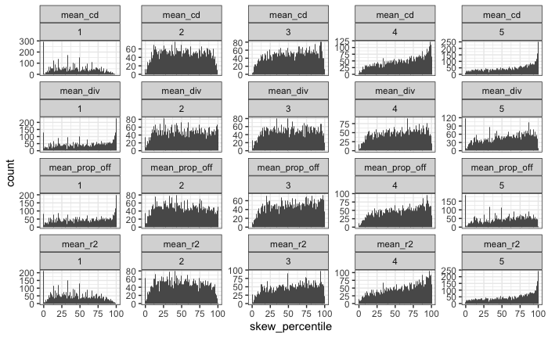

##### Figure 7: Skewness broken out by thresholded size of FS

Size of FS is broken into 10 bins by quantile. Facet labels are the maximum lognparts for that facet; so the 4.7 one is the 10% of communities with exp(3.5) – exp(4.7) parts.

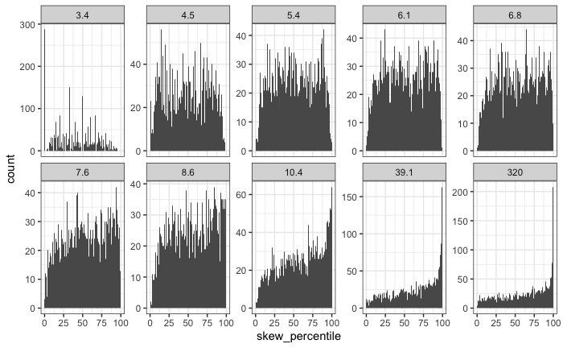

##### Figure 8: Simpson versus ROV

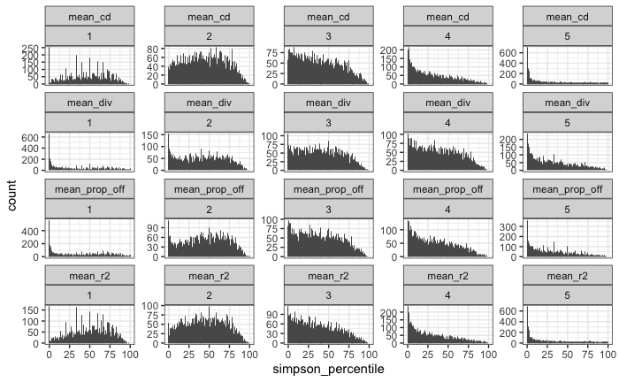

##### Figure 9: Simpson vs size of FS

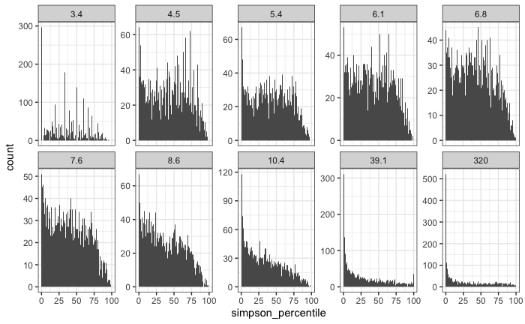

##### Figure 10: Skewness rarefaction change overall

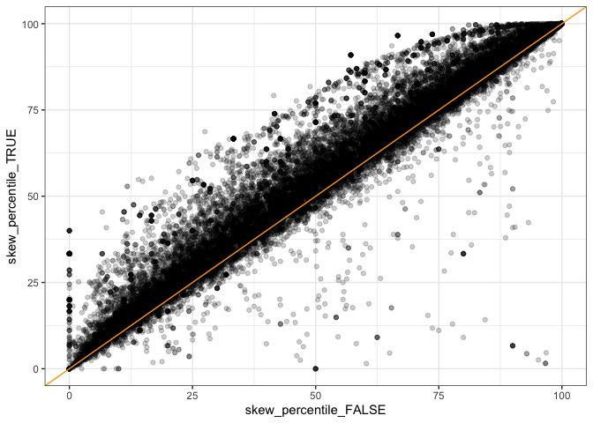

##### Figure 11: Simpson rarefaction change overall

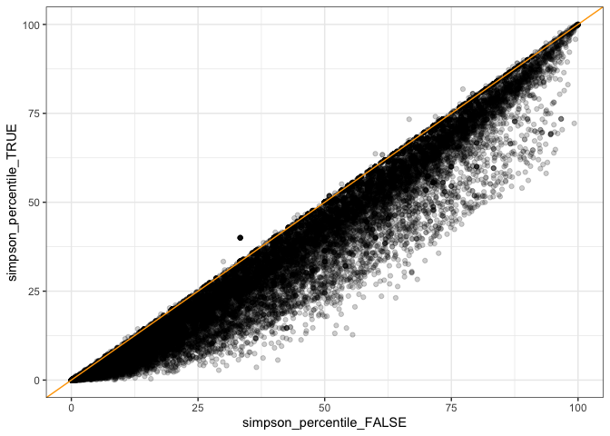

##### Figure 12: Simpson rarefaction by size of FS

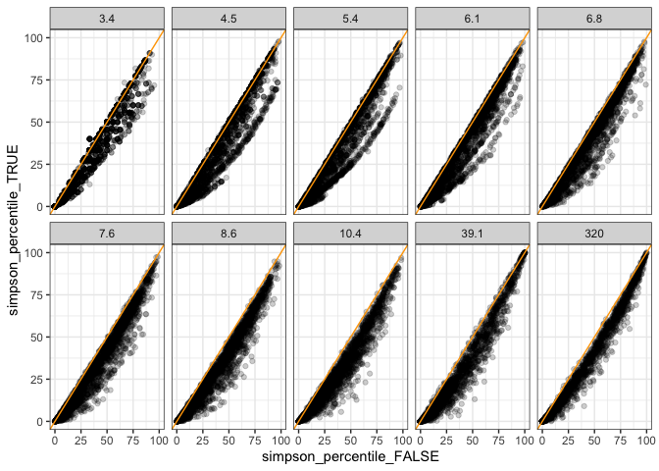

##### Figure 13: Skewness rarefaction change by size of FS

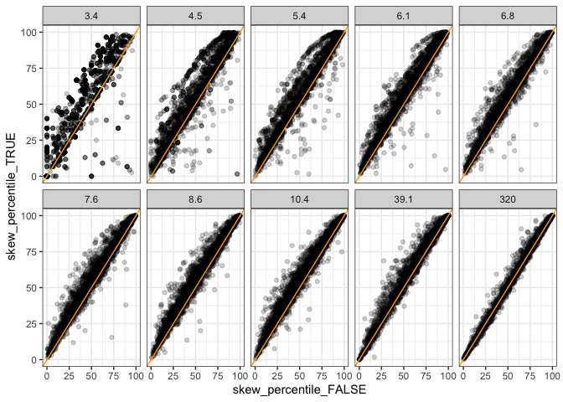

##### Figure 14: Skewness rarefaction change by S and N Green = rarefaction made the skewness percentile score go *down*

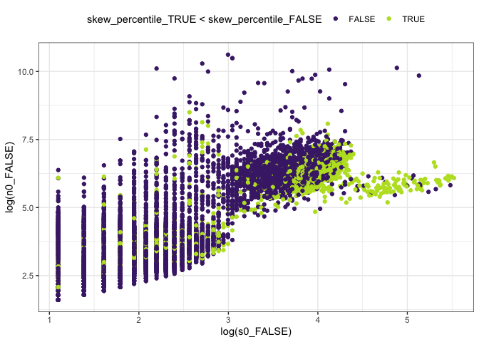

##### Figure 15: Rarefied skewness overall

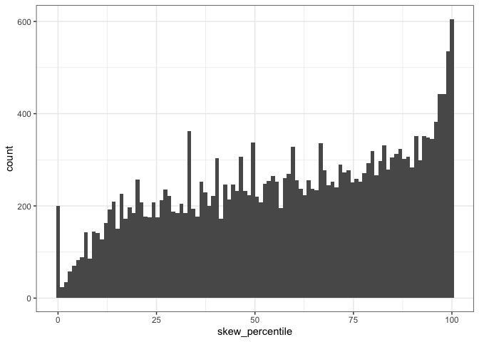

##### Figure 16: Rarefied evenness overall

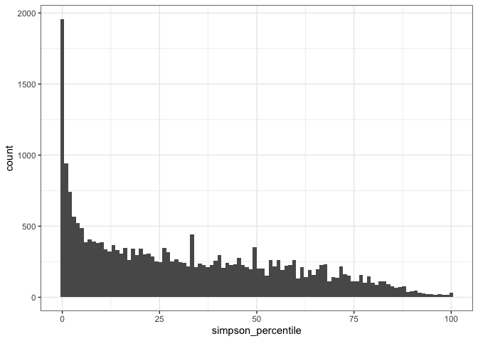

##### Table 1: Proportion of high/low %ile scores for raw vectors

Each qbin (**q**uantile **bin**) contains 1/10 of the communities, divided according to their number of parts. The bin cutoffs are the quantile values, and the bins are labeled according to their ceiling. So bin 3.4 is communities with up to exp(3.4) elements of the feasible set; bin 4.5 is communities with exp(3.4) – exp(4.5) elements, etc.

|  |  |  |  |  |
| --- | --- | --- | --- | --- |
| **qbinned_lognparts**  <ord> | **high_skew**  <dbl> | **Mean % high skew** | **low_simpson**  <dbl> | **Mean % low simpson** |
| 3.4 | 0.002145002 | 0.032 | 0.14671815 | 0.093 |
| 4.5 | 0.005966587 | 0.08711217 |
| 5.4 | 0.021093414 | 0.08824796 |
| 6.1 | 0.031839623 | 0.07311321 |
| 6.8 | 0.049509002 | 0.07692308 |
| 7.6 | 0.052173913 | 0.08737060 |
| 8.6 | 0.064155629 | 0.09478477 |
| 10.4 | 0.102647658 | 0.1505 | 0.14582485 | 0.251 |
| 39.1 | 0.173913043 | 0.27358491 |
| 320 | 0.175164474 | 0.33429276 |

##### Table 2: Proportion of high/low %ile scores with rarefaction

| **qbinned_lognparts**  <ord> | **high_skew**  <dbl> | **Mean % high skew** | **low_simpson**  <dbl> | **Mean % low simpson** |
| --- | --- | --- | --- | --- |
| 3.7 | 0.01030928 | 0.067 | 0.14144330 | 0.134 |
| 4.9 | 0.04293688 | 0.09832546 |
| 5.7 | 0.04755614 | 0.10171731 |
| 6.5 | 0.06222386 | 0.10456554 |
| 7.3 | 0.09323432 | 0.14975248 |
| 8.1 | 0.10764174 | 0.16269515 |
| 9.2 | 0.10412413 | 0.18089016 |
| 11.2 | 0.15765766 | 0.193 | 0.27027027 | 0.36 |
| 40.1 | 0.22764561 | 0.40401969 |
| 331.5 | 0.19491178 | 0.40664752 |